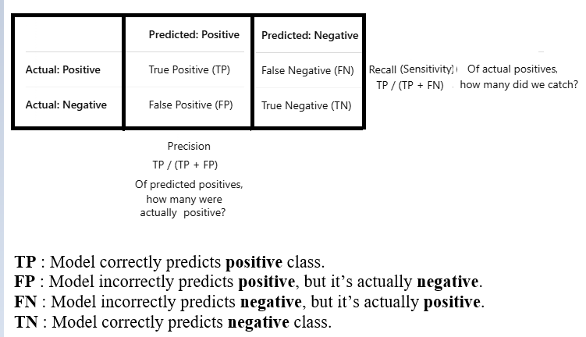

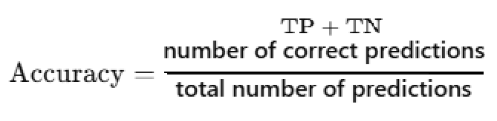

**Accuracy can be misleading** when your data is imbalanced (e.g., 95% of samples are negative). That’s when precision, recall, and F1 score become more useful.

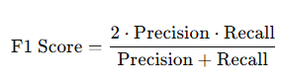

F1 Score is the harmonic mean of precision and recall.

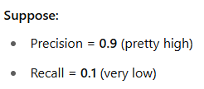

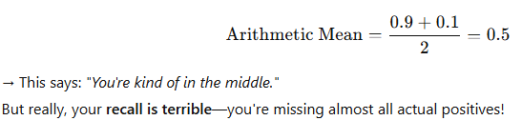

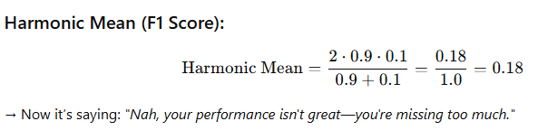

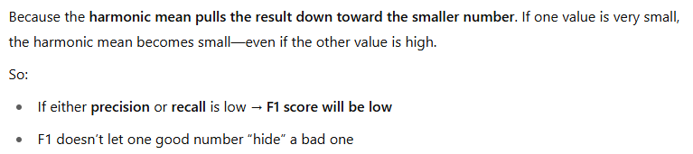

**That’s exactly what we want in classification:**

If a model is good at avoiding false positives (high precision), but terrible at catching actual positives (low recall), we don’t want to give it a free pass. The **F1 score**  balances that kind of situations.

